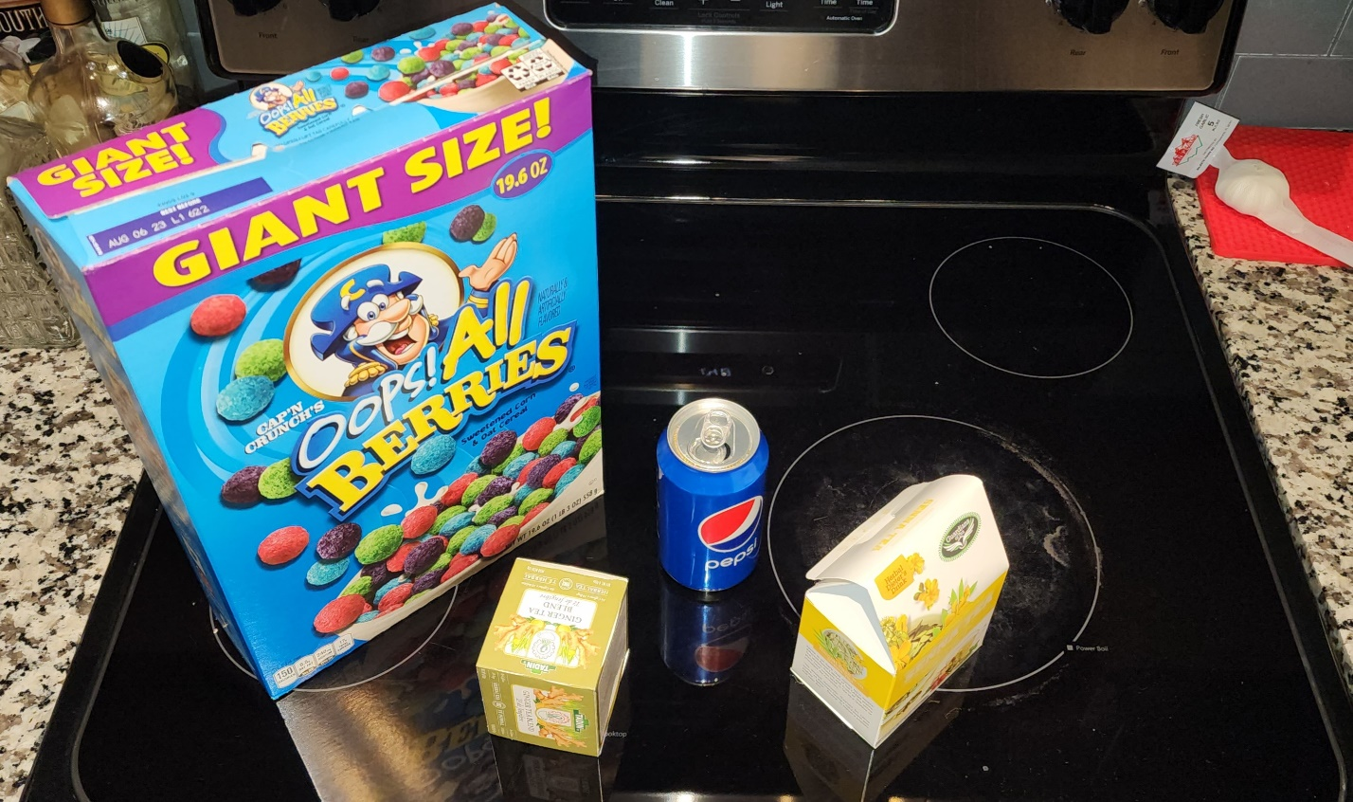

In my photo is a cereal box, tea box, a soda and a tea box which has a triangular top and swaure bottom. I feel these are easy to create my scene with. Basic shapes with not to many additional settings needed.

Shapes that I will use are rectangles, squares, cylinder, sphere, triangles and taurus’s. a plane will be used of course for the groundwork. I will accomplish this task by adding shading. Hopefully I can, but I’m up to the challenge.